Ex.No:1b | EDA-DATA IMPORT AND EXPORT

AIM:
To import data from various sources such as CSV, Excel, SQL, and Web, perform basic inspection using Pandas, and export the processed data into different file formats.

ALGORITHM:

Step 1: Import Pandas Library

Step 2: Load CSV file using read_csv()

Step 3: Display first few records

Step 4: Check data structure

Step 5: Analyze imported data

PROGRAM:
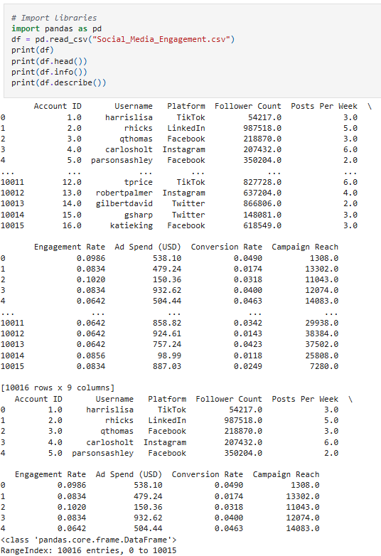
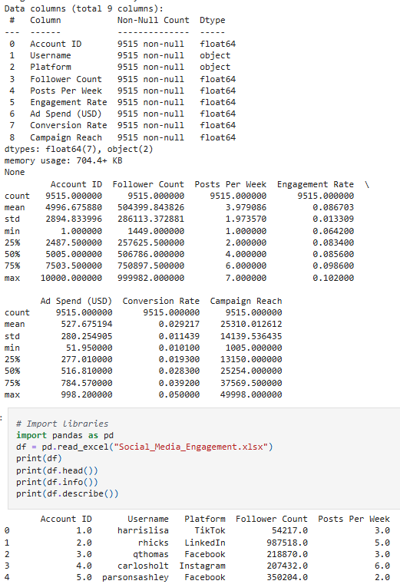

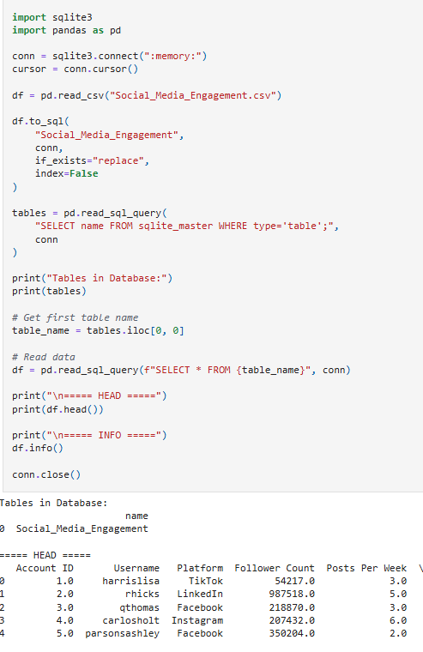
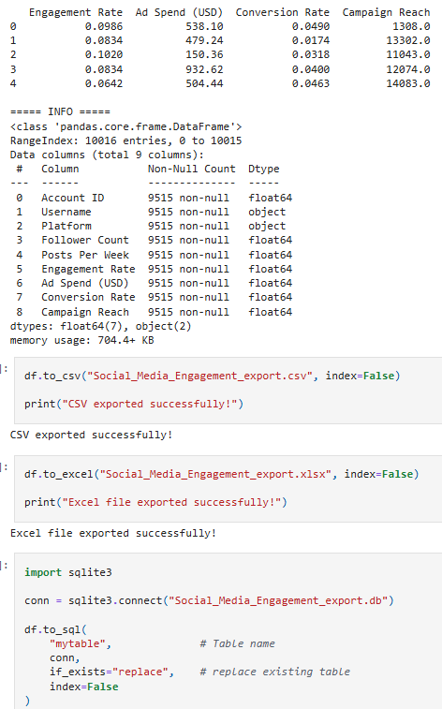
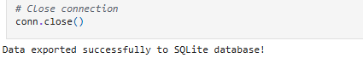

RESULT:
Thus, data was successfully imported from CSV, Excel, SQL, and Web sources using Pandas, and exported into different formats. The imported data was analyzed and visualized successfully.

